Day 2:

SQL Query

Query the *Name* of any student in **STUDENTS** who scored higher than  *Marks*. Order your output by the *last three characters* of each name. If two or more students both have names ending in the same last three characters (i.e.: Bobby, Robby, etc.), secondary sort them by ascending *ID*.

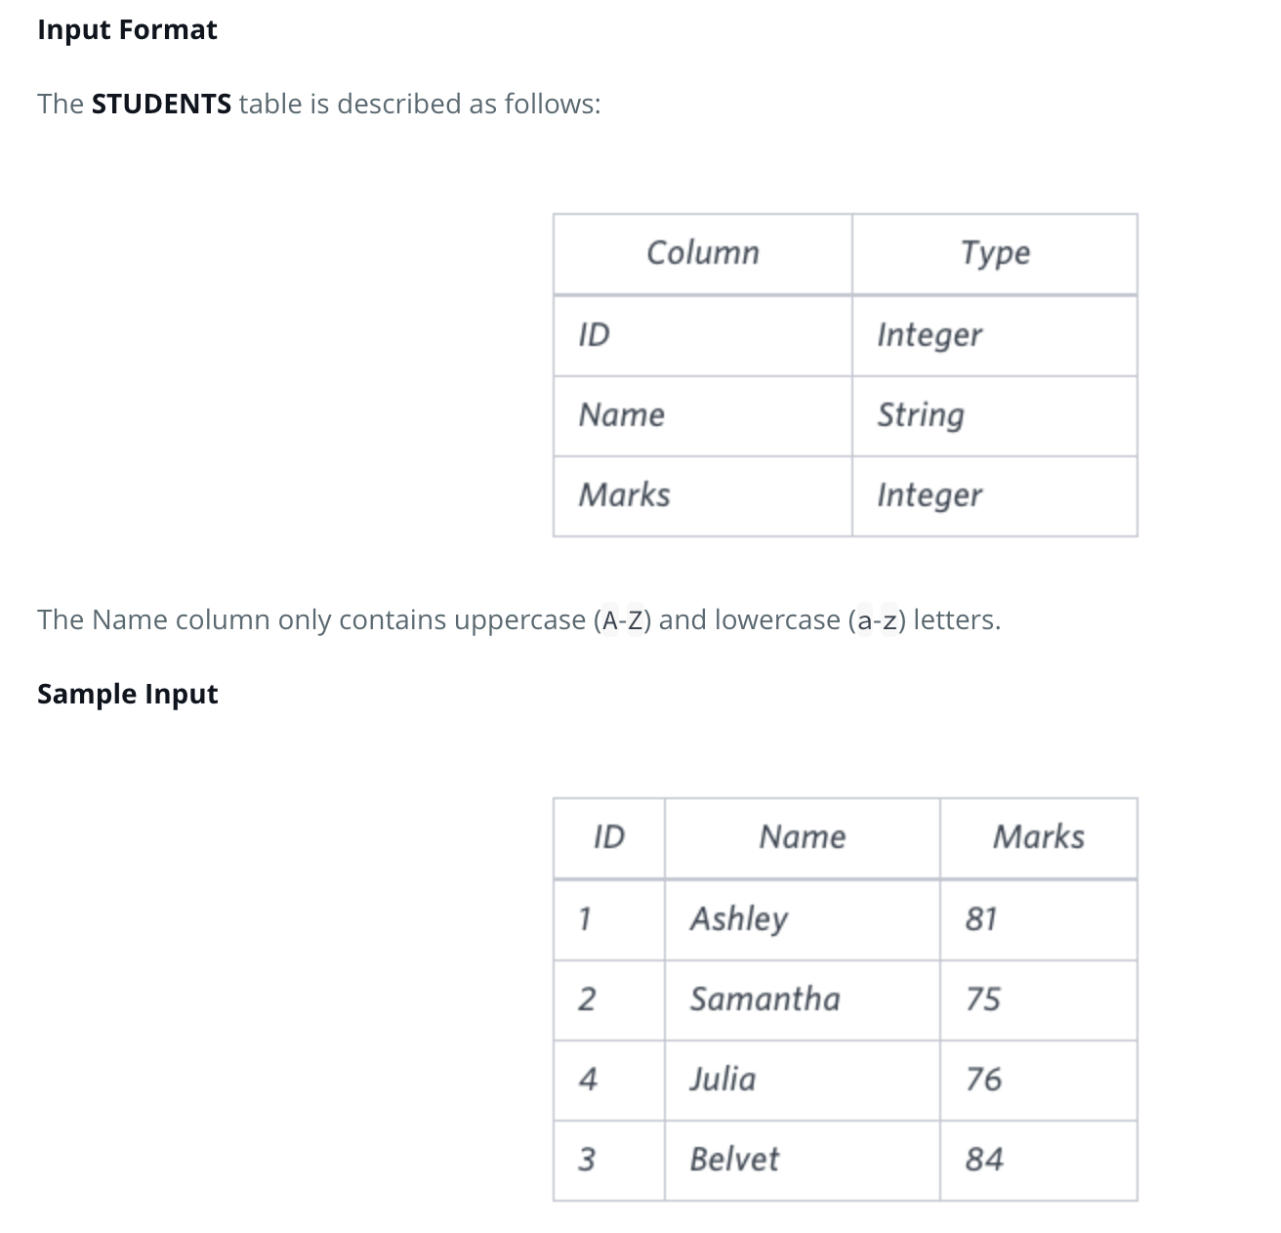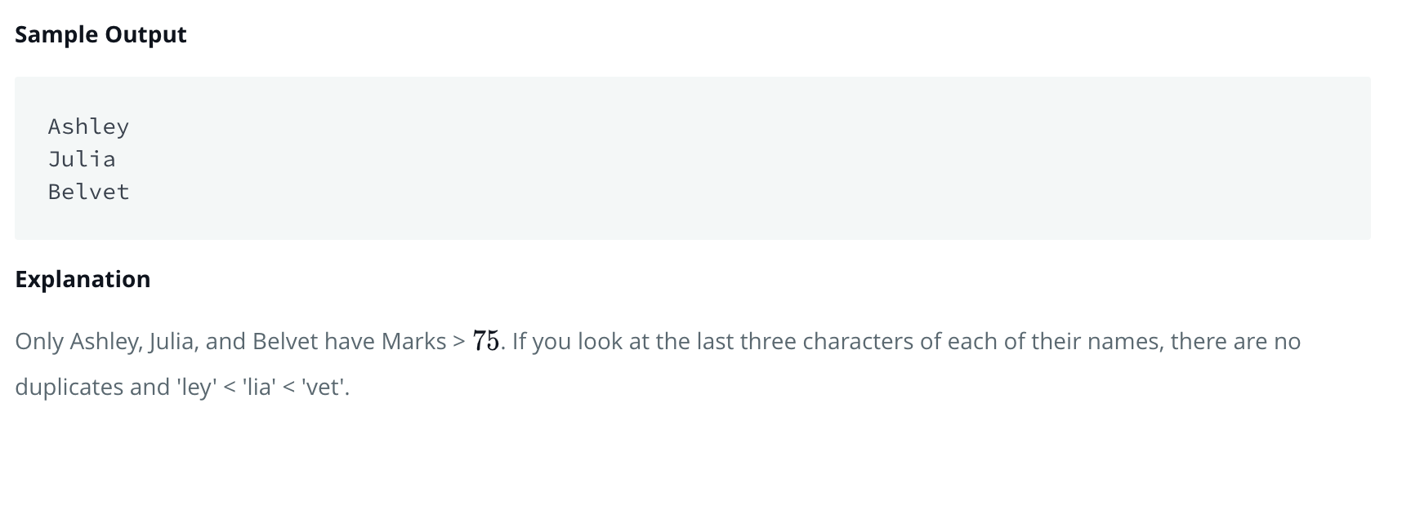

Query:

**select name**

**from students**

**where marks>75**

**order by right(name,3),id**